Algebra 1 Name ______________________________________
Intro to Section 2.5

Graph the compound inequality.
Compound Inequality “or” | Compound Inequality “and”
- $x>2 or x<-3$ | - $-3<x<2$
- $-5>c or c>1$ | - $1$ $>c>-5$
- $r≤0 or r≥5$ | - $0≤r≤5$
- $h<3 or h≥4$ | - $3<h≤4$
- $2.5≥v or v≥7$  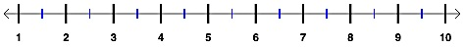 | - $7≥v≥2.5$
- $m≤\frac{2}{3 }or m≥\frac{5}{3}$ | - $\frac{2}{3}≤m≤\frac{5}{3}$

Determine whether or not the inequality is a “and” or “or” compound inequality. Then, write a compound inequality that describes the graph.
- Circle: and or  Inequality: ___________________________________ | - Circle: and or  - Inequality: ___________________________________
- Circle: and or  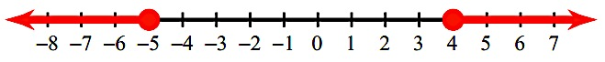  - Inequality: ___________________________________ | - Circle: and or  - Inequality: ___________________________________
- Circle: and or  Inequality: ___________________________________ | - Circle: and or  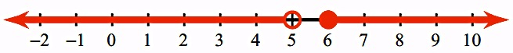  Inequality: ___________________________________
- Circle: and or  Inequality: ___________________________________ | - Circle: and or  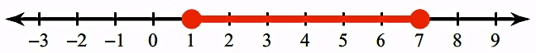  Inequality: ___________________________________

Write a compound inequality for the given real-life application.
- A ski shop carries skis that are between 150 and 220 cm long.
- When mounting street signs, regulations in Jeremy’s town states that signs must be shorter than 20 feet or taller than 35 feet so that they do not interfere with the power and phone lines.
- The ideal pH for the water in a swimming pool is between 7.0 and 7.6.

- Ralph needs to earn a B in his Geology class. His current test scores are 91, 94, 79, and 74. In order to earn a B, Ralph's average must lie between 83 and 92, inclusive. Did Ralph earn a B in his Geology class?  - Write a compound inequality describing a B average in Geology class.  - What is Ralph’s current score?  - Did Ralph get a B in Geology? | - When climbing the oxygen percentages decrease as elevation increases. If h represents the elevation, find the oxygen level that matches the compound inequality $25000<h≤50000$.  