Name Date

Review

Chapter

3

Determine whether the relation is a function. Explain.

1.  2. 

4. 5.

|  |  |  |  |  |
| --- | --- | --- | --- | --- |
| Input | −2 | 0 | 2 | −2 |
| Output | 10 | 7 | 4 | 1 |

|  |  |  |  |  |
| --- | --- | --- | --- | --- |
| *x* | 0 | 1 | 2 | 3 |
| *y* | −2 | 0 | 2 | 4 |

Find the domain and range of each relation, and determine whether or not the graph represents a function. Is the function discrete or continuous?

|  |  |  |
| --- | --- | --- |
| **TA: C:\2014 Projects\EPSs_PNGs_Word\Alg1\Arts\PNGs\HSAlg1_rbc_03cr_000.png6.**  Domain: \_\_\_\_\_\_\_\_\_\_\_\_\_\_\_\_\_\_  Range:\_\_\_\_\_\_\_\_\_\_\_\_\_\_\_\_\_\_\_\_  Function: Yes or No  Explain: \_\_\_\_\_\_\_\_\_\_\_\_\_\_\_\_\_\_\_\_ \_\_\_\_\_\_\_\_\_\_\_\_\_\_\_\_\_\_\_\_\_\_\_\_\_\_\_  Discrete or Continuous | **Macintosh HD:Users:hwills:Desktop:Screen Shot 2014-10-05 at 7.39.45 AM.png7**.  Domain: \_\_\_\_\_\_\_\_\_\_\_\_\_\_\_\_\_\_  Range:\_\_\_\_\_\_\_\_\_\_\_\_\_\_\_\_\_\_\_\_  Function: Yes or No  Explain: \_\_\_\_\_\_\_\_\_\_\_\_\_\_\_\_\_\_\_\_ \_\_\_\_\_\_\_\_\_\_\_\_\_\_\_\_\_\_\_\_\_\_\_\_\_\_\_  Discrete or Continuous | **TA: C:\2014 Projects\EPSs_PNGs_Word\Alg1\Arts\PNGs\HSAlg1_rbc_03cr_001.png8.**  Domain: \_\_\_\_\_\_\_\_\_\_\_\_\_\_\_\_\_\_  Range:\_\_\_\_\_\_\_\_\_\_\_\_\_\_\_\_\_\_\_\_  Function: Yes or No  Explain: \_\_\_\_\_\_\_\_\_\_\_\_\_\_\_\_\_\_\_\_ \_\_\_\_\_\_\_\_\_\_\_\_\_\_\_\_\_\_\_\_\_\_\_\_\_\_\_  Discrete or Continuous |

9. The function $a=700-20w$ represents the amount of money, *a,* left in your bank account after every $20, *w*, withdrawn from an ATM account.

a. Identify the independent and dependent variables.

b. Is it discrete or continuous function? Explain.

**c.** Identify the domain and range of function for no more then 6 withdraws.

Determine whether the relation or table represents a *linear* or *nonlinear function*. Explain.

10. 11.

|  |  |  |  |  |
| --- | --- | --- | --- | --- |
| Input | 2 | 4 | 6 | 8 |
| Output | 1 | 2 | 8 | 16 |

Determine whether the equation represents a *linear* or *nonlinear* function.

12.  13.  14.

Evaluate the function when 

15. 16. 

**Find the value of *x* so that the function has the given value.**

17.  18. 

Graph the linear function using a table of values.

19.  20.  21. 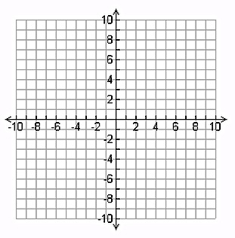  

22. The function **** represents the average speed, *f(x),* of a car that took a 108-mile trip in *x* hours.

a. Is this function continuous or discrete?

**b.** What was the average speed of the car if the trip took 3 hours?

c. How long did the trip take if the average speed was 54 miles per hour?

The following points lie on a line. Find the slope of the line.

23.  24. 

Use intercepts to graph the linear equation. Label the points corresponding to the intercepts.

25.  26.  27. 

|  |  |  |
| --- | --- | --- |
| x-intercept=\_\_\_\_\_\_\_\_\_\_\_\_\_\_\_\_  y-intercept=\_\_\_\_\_\_\_\_\_\_\_\_\_\_\_\_ | x-intercept=\_\_\_\_\_\_\_\_\_\_\_\_\_\_\_\_  y-intercept=\_\_\_\_\_\_\_\_\_\_\_\_\_\_\_\_ | x-intercept=\_\_\_\_\_\_\_\_\_\_\_\_\_\_\_\_  y-intercept=\_\_\_\_\_\_\_\_\_\_\_\_\_\_\_\_ |

  

**28.** You are ordering warm-up clothes for the basketball team. The mesh shirts cost   
$16 each and the cotton shirts cost $8 each. You have a budget of $240 for the shirts. The equation  models the total cost, where *x* is the number of mesh shirts and *y* is the number of cotton shirts.

a. Graph the equation. Interpret the intercepts.

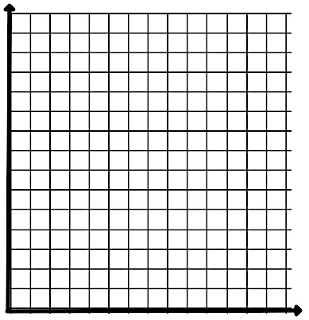

b. Four players decide they want the cotton shirts. How many mesh shirts can   
you order?

Find the slope and *y*-intercept. Then graph the linear equation.

29.  30.  31. 

|  |  |  |
| --- | --- | --- |
| m=\_\_\_\_\_\_\_\_\_\_\_\_\_\_\_\_  b=\_\_\_\_\_\_\_\_\_\_\_\_\_\_\_\_ | m=\_\_\_\_\_\_\_\_\_\_\_\_\_\_\_\_  b=\_\_\_\_\_\_\_\_\_\_\_\_\_\_\_\_ | m=\_\_\_\_\_\_\_\_\_\_\_\_\_\_\_\_  b=\_\_\_\_\_\_\_\_\_\_\_\_\_\_\_\_ |

  

**32.** Function A represents the amount of money spent after purchasing a certain amount of the same candy bar(s). Function B represents the distance after running at a consistent rate over a period of time. Compare the domains.